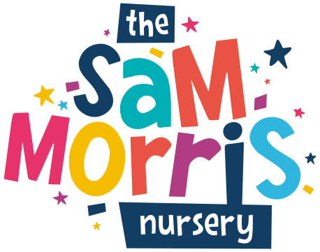

APPLICATION FOR AN OUT-OF-BOROUGH PLACE

Child’s first name(s)
Child’s family name
Date of birth
Child’s home address
Name and daytime ‘phone number | Mother:  Father:  Other:
Does your child have any special needs? Please specify:
When do you wish your child to start at the Nursery?

Days/hours you would like your child to attend | MORNING | AFTERNOON
Monday
Tuesday
Wednesday
Thursday
Friday

Signed (Parent/Carer)
Date of application

COMMUNITY PLACE FEES

To be eligible for a community place, subsidised by Islington Council, you must live in Islington.

Community place fees follow Islington’s recommendations which they frequently update. There are different income bands and you can discuss your own child’s fees with the Coordinator.

The prices quoted are for a full-time place and are adjusted for a part-time place. Fees must be paid by Direct Debit (exceptionally by cash), and payment must be received in advance. We will ask you for a deposit of four weeks’ fees when you accept a place and this will be refunded provided you give us one month’s notice before your child leaves.

The Nursery is open for 49 weeks each year. It is closed on bank holidays, for 5 days over Christmas and for two weeks in the summer, usually the last two weeks in August. Fees are payable for all bank holidays and the Christmas closure, but not for the summer break. However, the cost is spread out over 52 weeks.
We have an admissions policy which forms a part of our Certificate of Registration and which is freely available for you to see.

ADMISSIONS CRITERIA

- Islington states that five places must be allocated to working parents or carers.
- Children of non-working parents or carers will only be offered part-time places. There is only a small percentage of our intake available for full-time students.
- Only families living within the Islington area can put their names on the waiting list for a community place.
- You must provide proof of income.

APPLICATION FOR A COMMUNITY PLACE

Child’s first name(s)
Child’s family name
Date of birth
Child’s home address
Name and daytime ‘phone number | Mother:  Father:  Other:
Does your child have any special needs? Please specify:
When do you wish your child to start at the Nursery?
Gross family income

Days/hours you would like your child to attend | MORNING | AFTERNOON
Monday
Tuesday
Wednesday
Thursday
Friday

Signed (Parent/Carer)
Date of application

